**PROJECT REPORT TEMPLATE**

**A COMPREHENSIVE ANALYSIS OF FINANCIAL PERFOMANCE : INSIGHTS FROM A LEADING BANKS**

1. **INTRODUCTION**

OVERVIEW:

The purpose of this study is to investigate the relationship between selected board characteristics and ownership elements and the performance of firms listed in the Muscat Securities Market (MSM30). The examination focused on how the firm financial performance was affected by the board size, the number of board meetings and the ratio of the independent board of directors along to the ownership concentration types (i.e. institutional, state and concentrated individual ).

PURPOSE:

Studies on the influence of corporate governance and ownership structures in the context of Oman are still scarce. MSM30 received little attention, even though such an index encompasses the most liquid and the most profitable firms. MSM30 is an important index for investors in Oman looking for capital gains. Accordingly, this present study contributes to the knowledge body by providing new findings related to Oman and compares it with the other markets within Gulf Council Countries (GCC) and around the world. This will provide more understanding of the Omani context. Moreover, the authors anticipate that the outcomes of this research, which so far is the most comprehensive study in the Omani context in terms of the impact of corporate governance and ownership structure on firm financial performance can significantly shape corporate governance discourse, practices and policies in Oman, in particular, and in other GCC countries in general, to improve financial performance and corporate sustainability.:

1. **PROBLEM DEFINITIO&DESIGN THINKING EMPATHY MAP:**

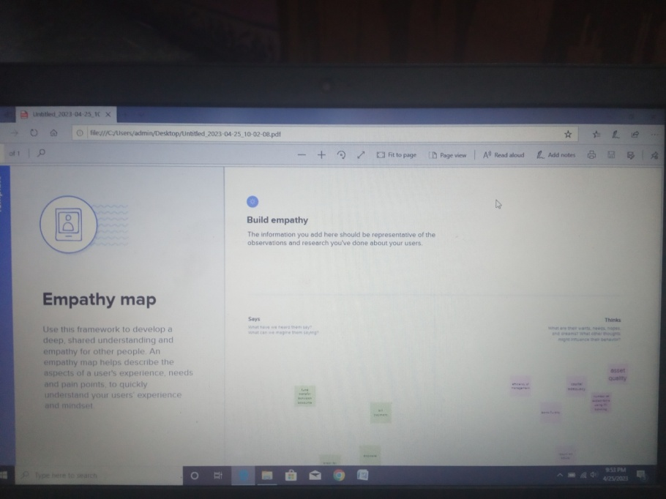

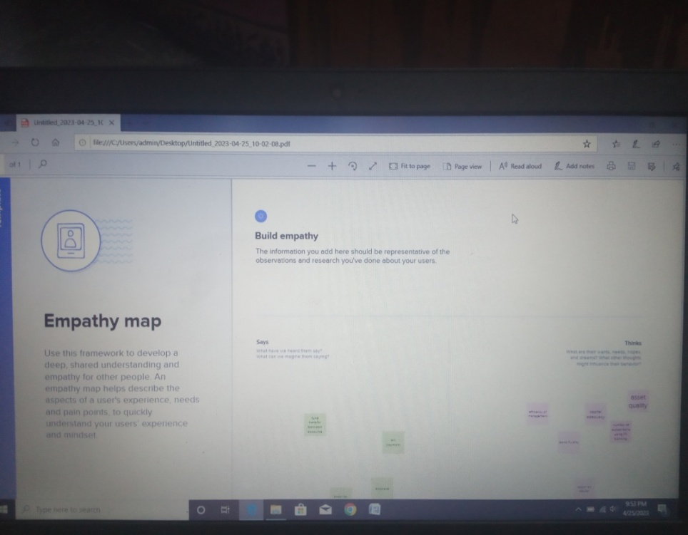

IDEATION&BRAINSTORMING:

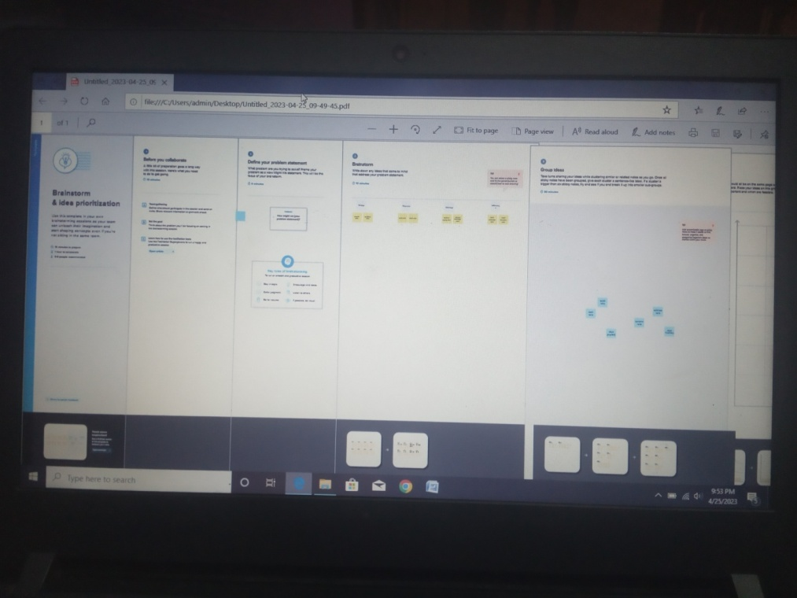

1. **RESULT(OUTPUT SCREEN SHOTS):**

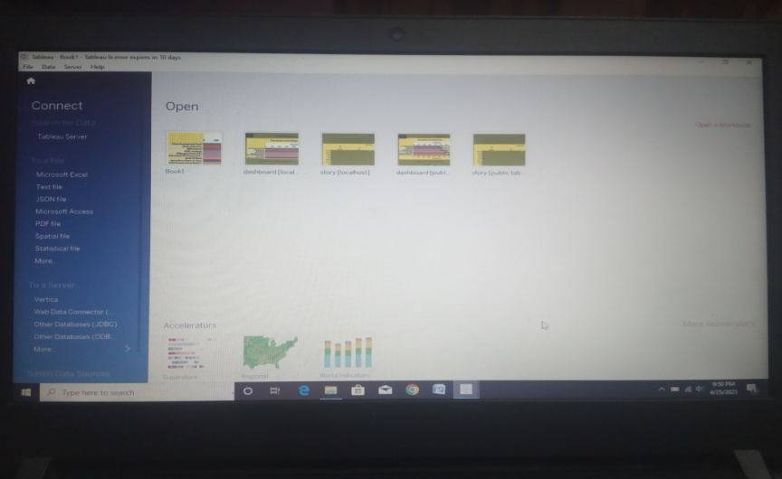

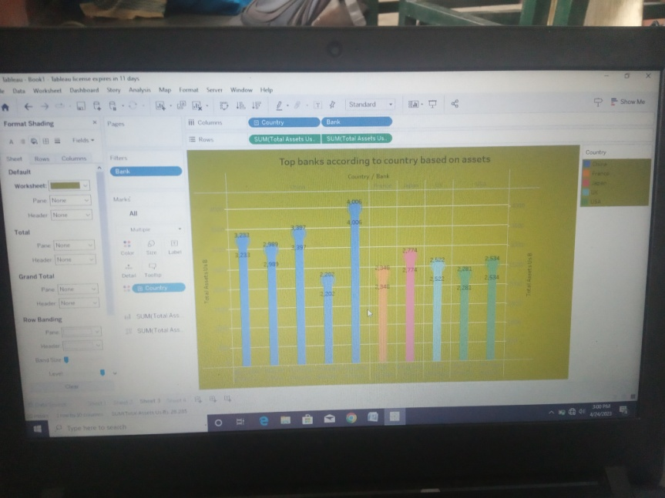

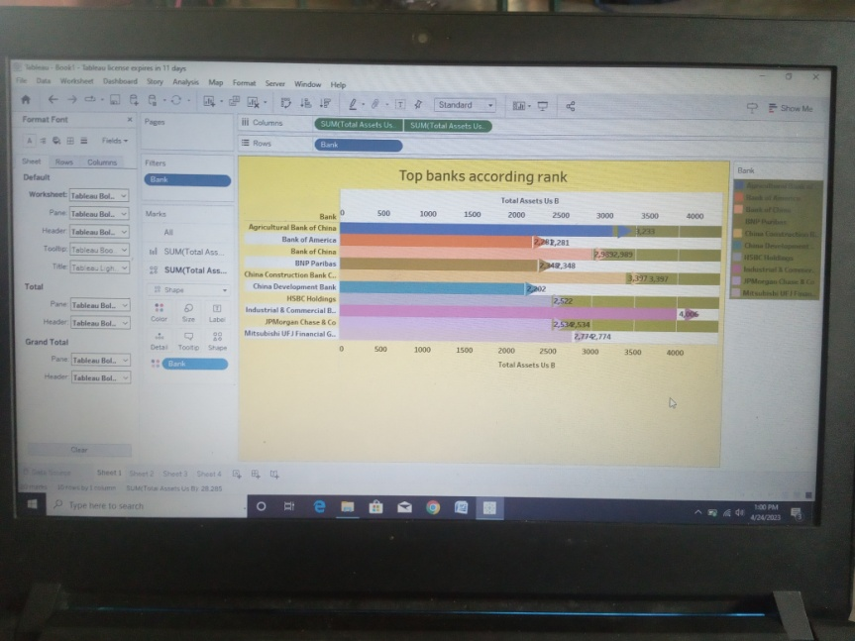

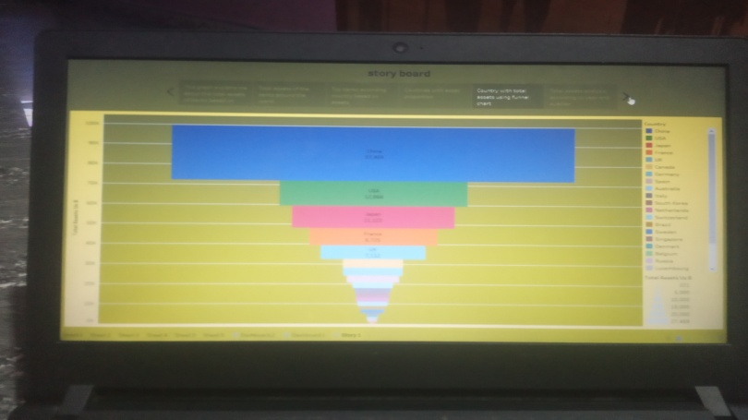



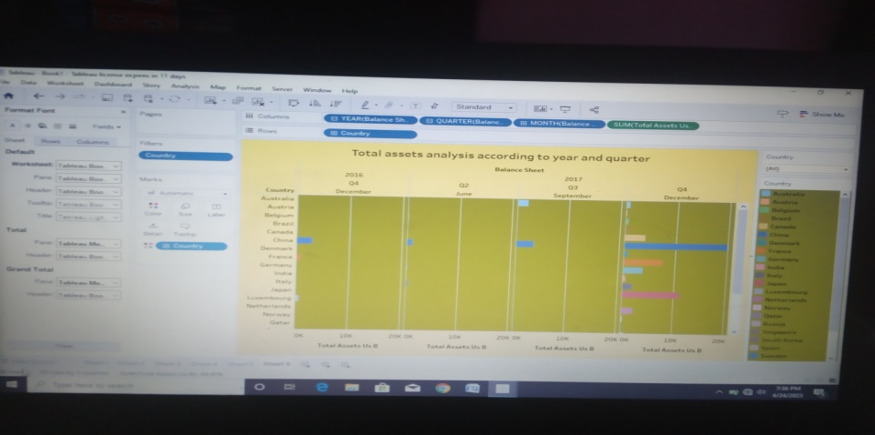

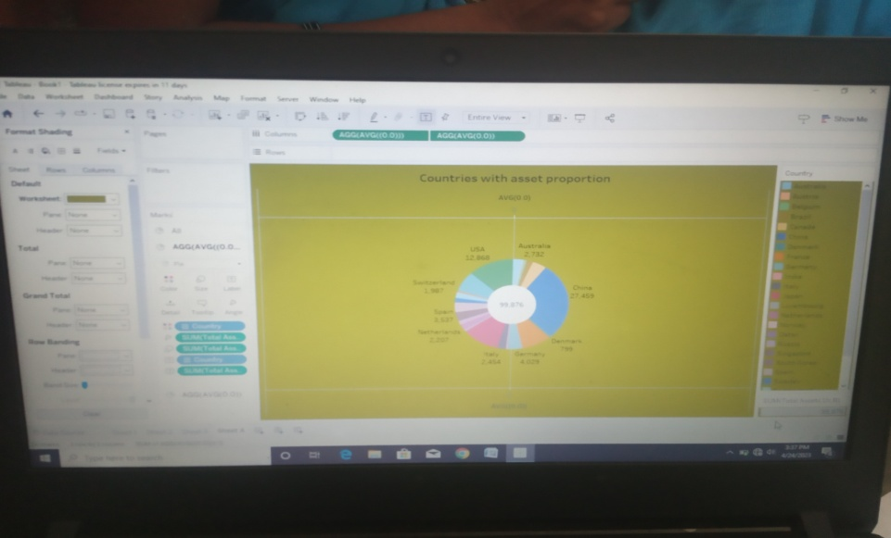

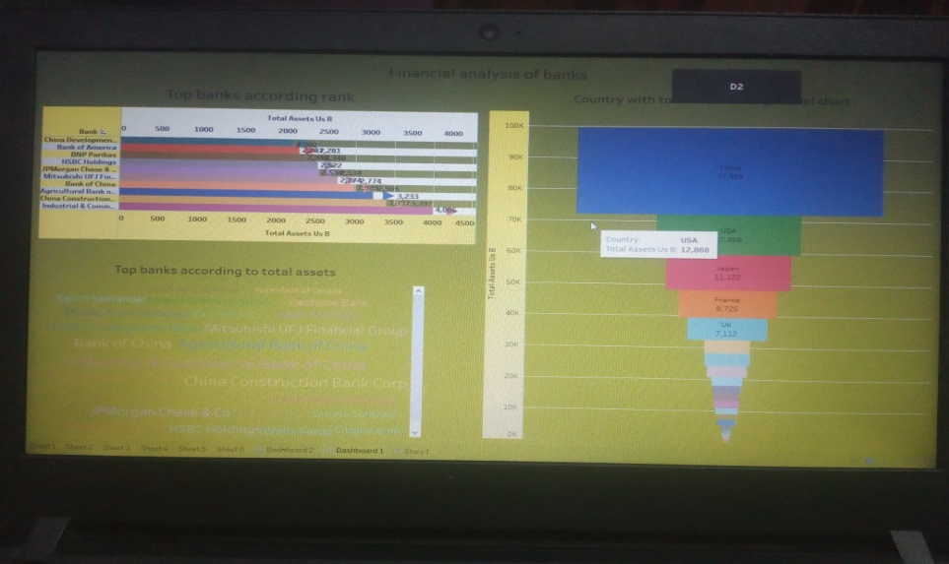

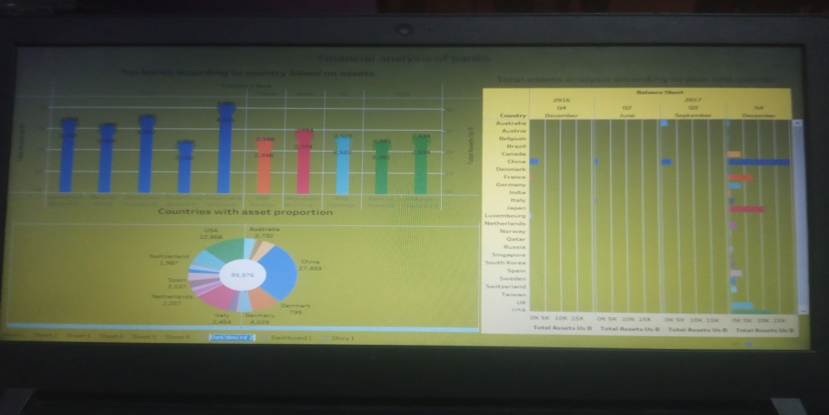

1. **ADVANTAGES&DISADVANTAGES:**

Financial statements are financial data documents a company publishes on an annual, biannual, quarterly or monthly basis. These documents include the company’s net worth based on assets and liabilities, as well as the company’s expenses, earnings and operational budget. Financial planners, senior executives and accountants may use financial statements to make decisions regarding future planning, expansions and product launches, but there are disadvantages to using this method.

Financial statements reveal how much a company earns per year in sales. The sales may fluctuate, but financial planners should be able to identify a pattern over years of sales figures. For example, the company may have a pattern of increased sales when a new product is released. The sales may drop after a year or so of being on the market. This is beneficial, as it shows potential and sales patterns so executives know to expect a drop in sales.

One disadvantage of using financial statements for decision making is that the data and figures are based on the market at that given time. Depending on the market, it may change quickly, so executives should not assume that the numbers from a previous financial statement will remain the same or increase. Just because a company has sold 5 million copies of a product during one year does not guarantee it will sell the same amount or more. It may sell much less if a competitor releases a similar product.

1. **CONCLUSION:**

 Analysis of financial statements is extremely important for every business to grow and increase their revenue. It should not be compromised since it increases the efficiency of business operations. Better processes and expert analysts can help in the detailed analysis process.

Ratio analysis helps interpret the financial data of a company to understand its true standing. Using ratio analysis, one can determine a company's liquidity, profitability and overall performance. It is also an important tool for investors to understand the worth of a company when investing